
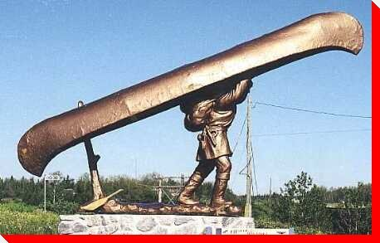
#3
Les Voyagers
Mike Ford
from the album “Canada Needs You - vol. 1”

MapleMusicRecordings

Vocabulary

1.belch -
2. gunnels -
3. adieu adieu -
4. muskeg -

Do You Know It?

Places to Know and Map:

- Montreal
- Ottawa
- Mattawa
- Georgian Bay
- Sault Ste Marie
- Michimilimackinaw
- Lake Superior
- Nipissing

Do You Know It – Part II

What is meant by the following expressions?

- birch-bark station wagon
- rendez-vous
- tump-lined wannigan
- bug filled pemmican
- hard tack
- skeeters
- en roulant ma boule dans un canot qui coule
- la vie damnee des engages
- L’oeil de la mort sur les homes du nord
- Rum kegger

Did You Catch It?

- How many men could fit into the voyageur’s canoe?
- How long was the voyageur’s trip?
- Where did the trip begin?
- How much weight could a voyageur carry during a portage?
- Which fur bearing animals are mentioned?

Do You Get It?

- Why do you think tobacco important tool for the voyageurs?

- What is the significance of fourteen white crosses on the shore?

- While on their journey, what luxuries did the voyageurs yearn for?

- What modern day occupations are similar to the voyageur’s job?

- Who do you think Gitchi Goomi is?

Activities and Extensions!

- Make a trivial pursuit board game using information from this song.

- Create a dance using the music.

- Rehearse the song using spoons as rhythm instruments.

- Create a recipe for salt-pork stew.

- Create a comic strip related to the voyageurs.

- Compare and contrast the journeys of the Voyageurs to long-distance semi drivers today. What luxuries do truckers look forward to?



Teacher’s Guide

BACKGROUND INFORMATION

SEE - VOYAGEUR SUPPLEMENT SHEETS

ANSWER KEY

DID YOU CATCH IT?

The canoes would hold 12 men.

The trip would last 6 weeks (42 days)

The trip would begin in Montreal

A voyageur could carry more than 80lbs during a portage. The weight would be carried across the forehead using a belt (see photo on the next page)

The fur-bearing animals mentioned in the song were: martins, otters, rats, raccoons, squirrels, beavers, deer, lynx, and mink. Note: some of these furs were not trade items, and other furs were, such as bear skin.

DO YOU GET IT?
- Tabacoo was used to keep insects away from them. It was/is also an important part of Native culture. Tobacco is used by Aboriginal peoples as a gift back to nature when something is taken from the Earth for life. ex) killing an animal for food and materials.
- Fourteen white crosses on the shore represents the voyageurs that have died due to the dangers and risks that accompany the Voyageur livelihood.
- During their journeys, the Voyageurs yearned for a fire, foot massage, a pipe, and a game of Trivial Pursuit (joke).
- Student answers will vary.
- Student answers will vary.

ARTIST INFORMATION

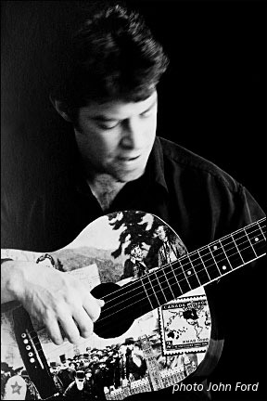
Mike Ford is a Juno-nominated artist whose concerts and recordings are garnering critical and popular acclaim coast-to-coast. Known to many as 1/4 of the eccentrically successful folk-pop-vaudeville band Moxy Früvous, Mike has embarked on a whole new career phase with his rollicking Canada In Song project. Les Voyageurs appears on his MapleMusic Recording Canada Needs You, volume one (a Juno-nominated romp through Canadian History) are filled with provocative original compositions delivered in a multitude of styles. Mike's interactive concerts for Intermediate and Senior Canadian Studies, Music and French students are all the rage in schools across the country (in these shows he's currently debuting new Canadian History originals for volume two of Canada Needs You).

Source: www.mikeford.ca

